Module 6: ASP.NET Core 8.0 Web API – Learning Objectives

1. Concept of RESTful Web Service, Web API & Microservice

RESTful Web Service
REST (Representational State Transfer) is an architectural style for designing networked applications. It uses standard HTTP methods (GET, POST, PUT, DELETE) and stateless communication.
Key Features of REST:
Stateless: Each request from client to server must contain all the information to understand and process the request.
Representation: Data is represented in formats like JSON or XML.
Uniform Interface: Uses standard HTTP methods and URIs.
Resource-Based: Everything is treated as a resource (e.g., /products/5).

Web API
Web API is a framework for building HTTP services in ASP.NET Core that can be accessed by a broad range of clients, including browsers, mobile apps, and other servers.
Key Points:
Built using REST principles
Supports JSON/XML (not restricted to XML)
Lightweight and ideal for mobile/web apps

Microservice
A Microservice is a small, independently deployable service that handles a specific business functionality. Web APIs are commonly used to implement microservices.
Benefits of Microservices:
Scalability
Independent deployment
Technology flexibility

2. What is HttpRequest & HttpResponse

HttpRequest:
Represents the incoming HTTP request. It includes:
Request headers
URL and query strings
HTTP method (GET, POST, etc.)
Request body (for POST/PUT)

HttpResponse:
Represents the response sent from the server to the client. It includes:
Status code (e.g., 200 OK)
Headers
Response body (e.g., JSON data)

3. Types of Action Verbs

🔹 HTTP Methods Used in Web API:
- GET
2. POST
3. PUT
4. DELETE
4. Types of HTTP Status Codes Used in Web API
1.200 OK
2.400 BadRequest
3.401 Unauthorized
4.500 InternalServerError
5. Demonstration: Simple Web API with Read/Write Actions :
Controller Structure:
CODE:
[ApiController]
[Route("[controller]")]
public class SampleController : ControllerBase
{
private static List<string> items = new List<string> { "Item1", "Item2" };
[HttpGet]
public IActionResult GetItems()
{
return Ok(items); }
[HttpPost]
public IActionResult AddItem([FromBody] string item)
{
items.Add(item);
return Ok(items);
}

}
6. Configuration Files in ASP.NET Core Web API

Program.cs & Startup.cs (ASP.NET Core <=5.0)
Registers services using Dependency Injection.
Configures Middleware (e.g., routing, authentication, exception handling)
public void ConfigureServices(IServiceCollection services)
{
services.AddControllers();
}

public void Configure(IApplicationBuilder app, IWebHostEnvironment env)
{
app.UseRouting();
app.UseEndpoints(endpoints => { endpoints.MapControllers(); });
}
appsettings.json:
{
"ConnectionStrings": {
"Default": "Data Source=app.db"
},
"Jwt": {
"Key": "SuperSecretKey123"
}
}
launchSettings.json:
"profiles": {
"FirstWebAPI": {
"commandName": "Project",
"launchBrowser": true,
"applicationUrl": "https://localhost:5001",
"environmentVariables": {
"ASPNETCORE_ENVIRONMENT": "Development"
}
}
}
- OUTPUT:
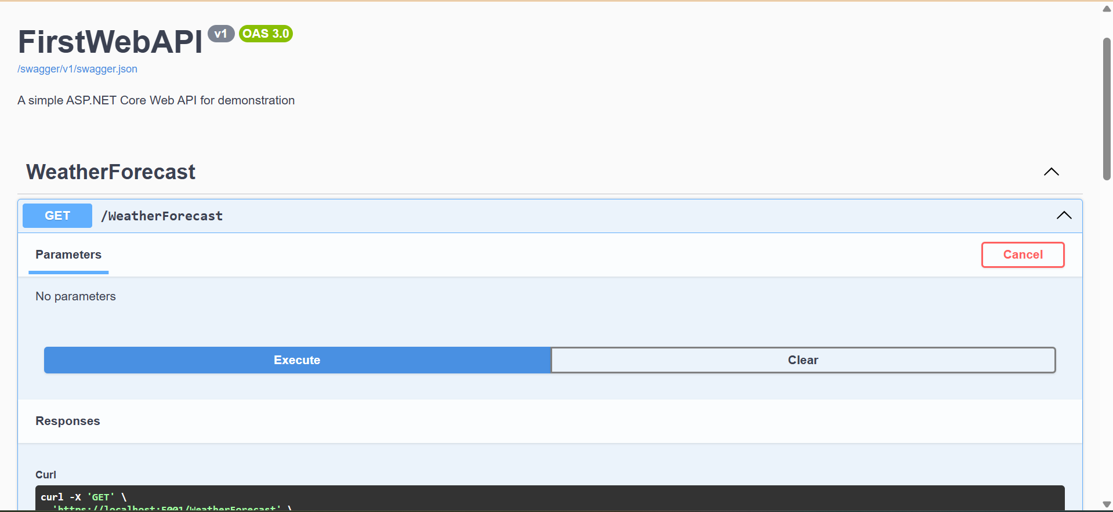
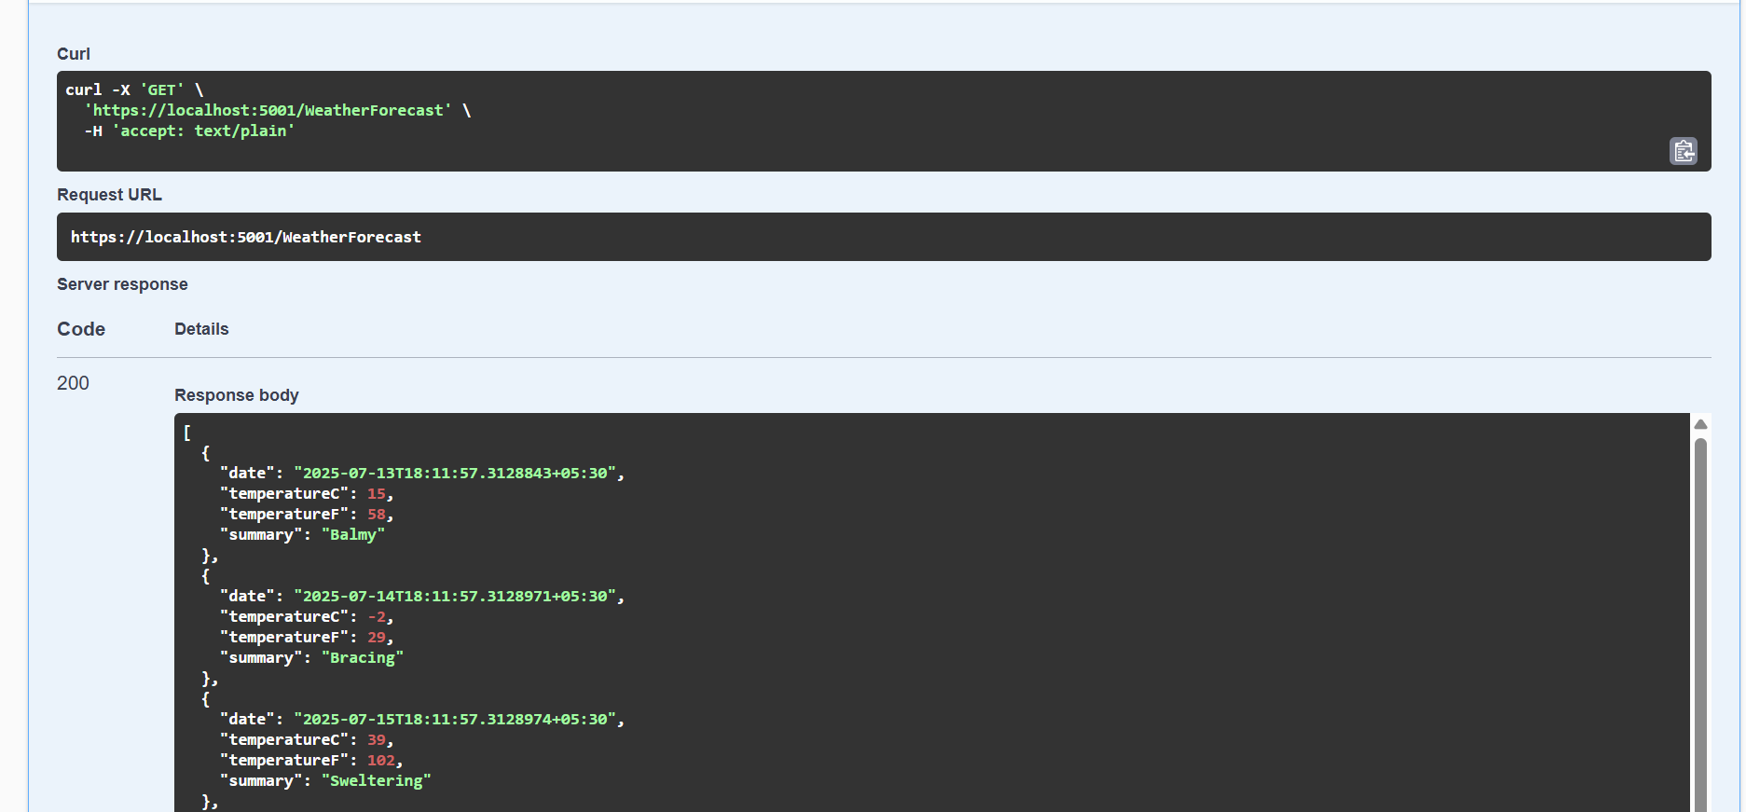
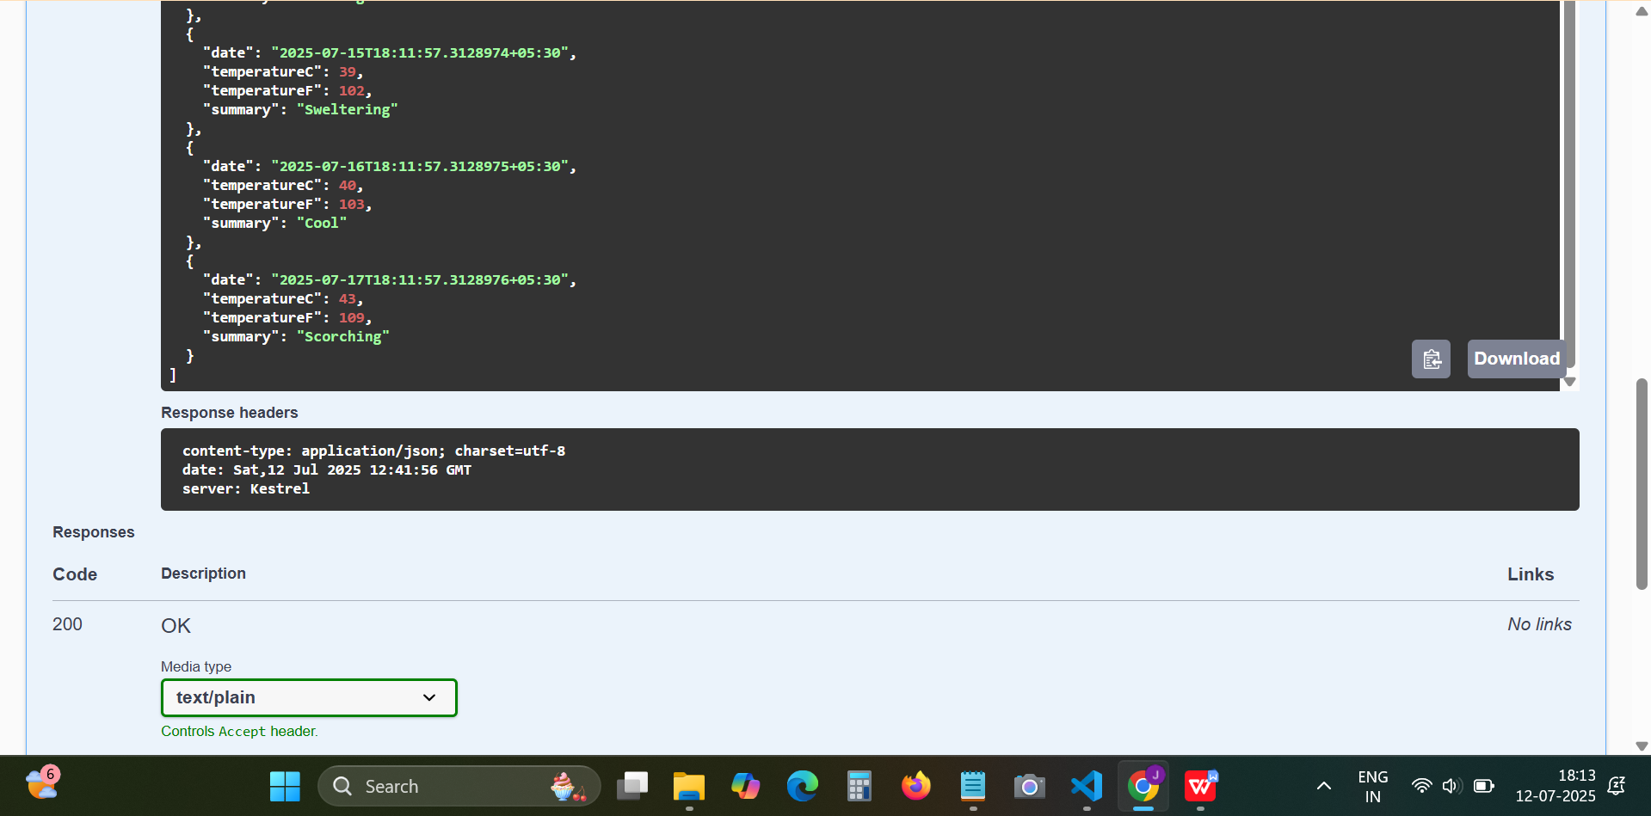
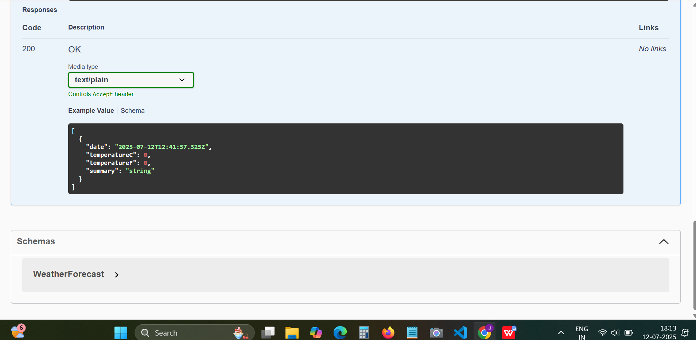
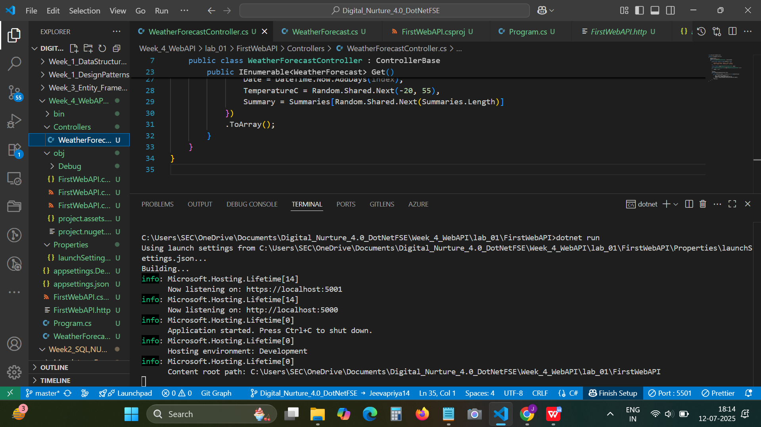
2.LAB_02
OUTPUT:
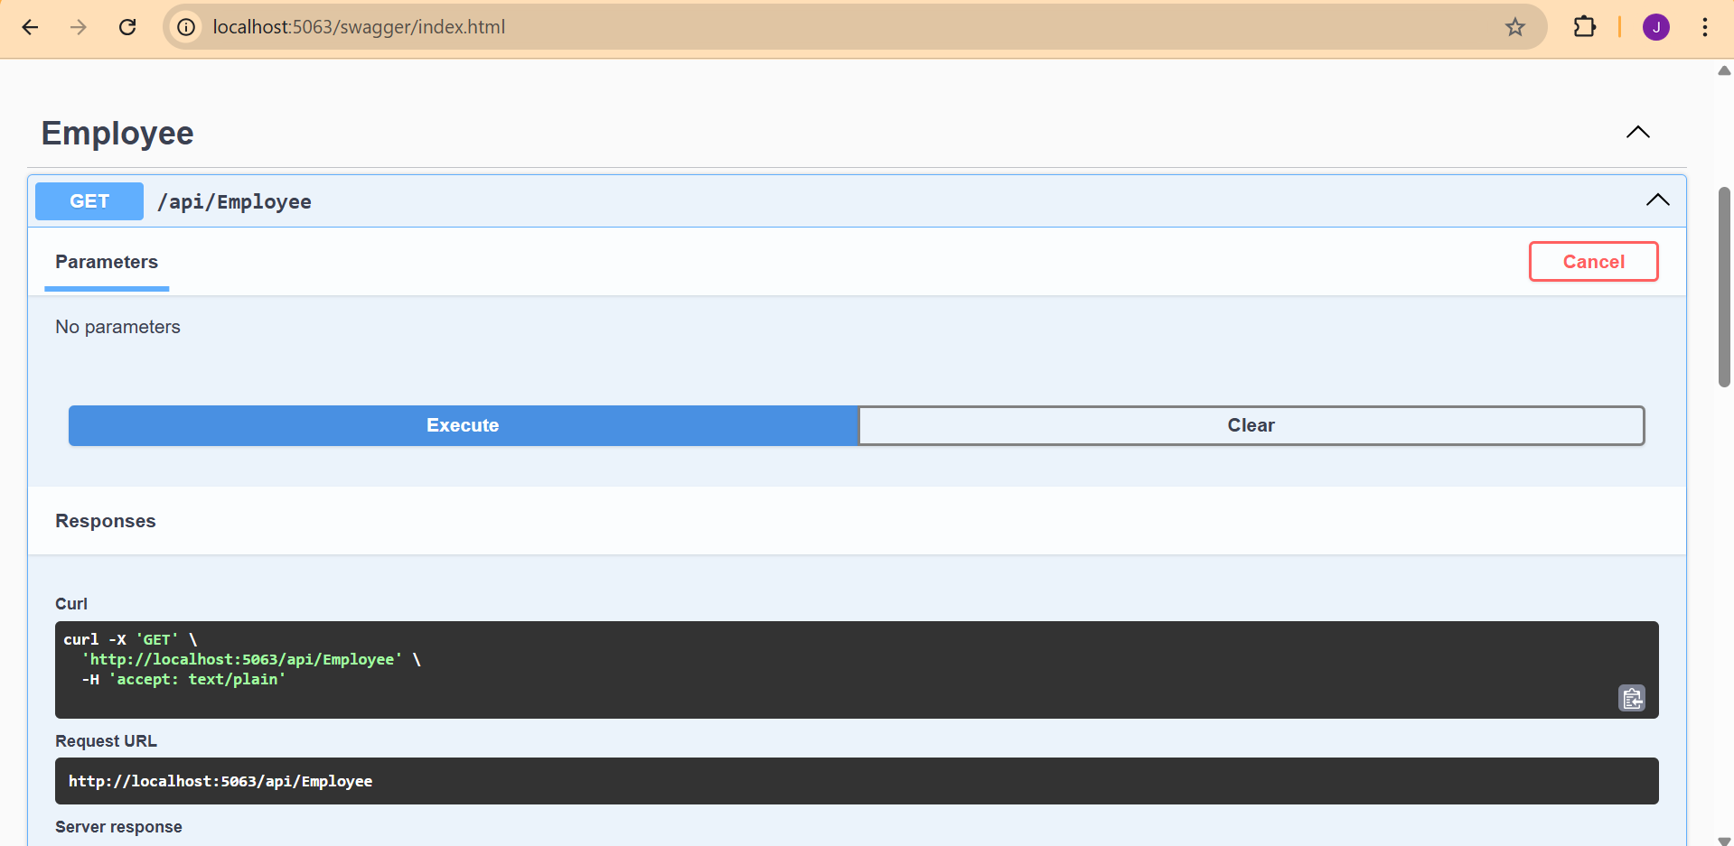
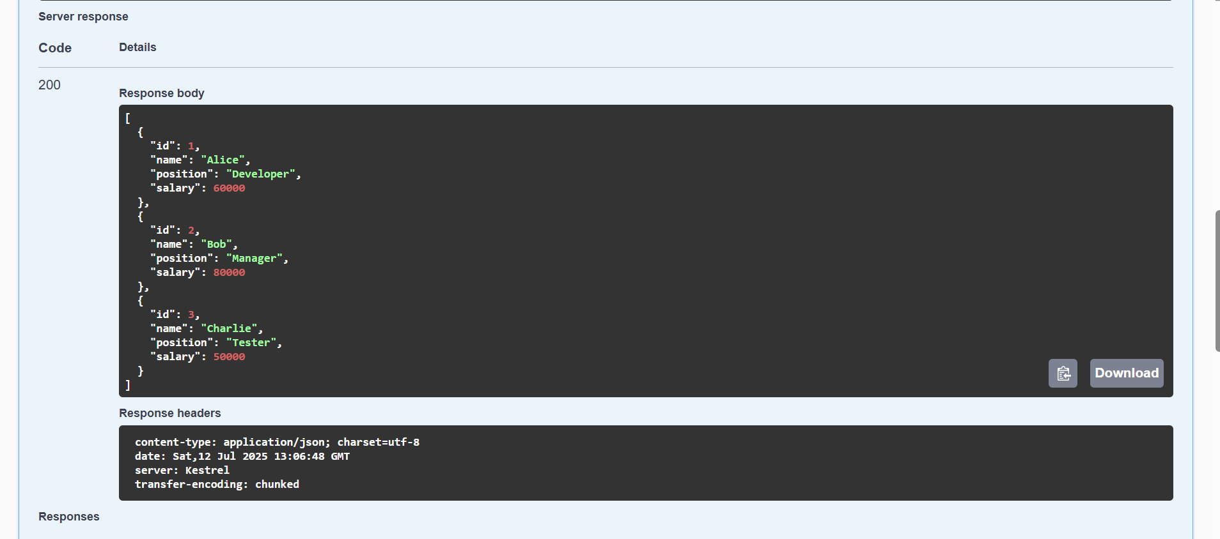
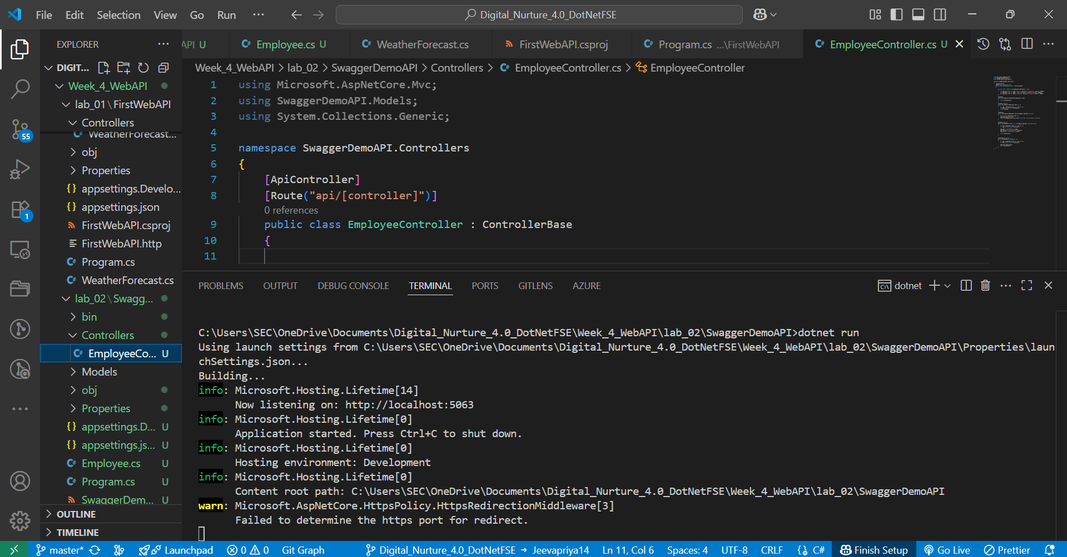
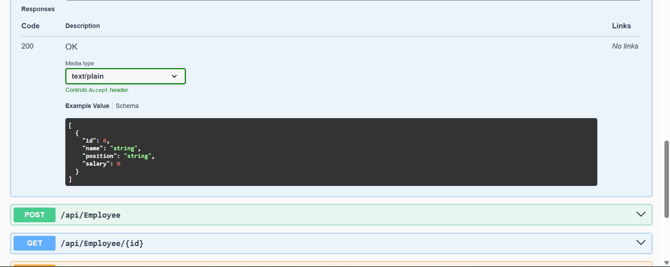
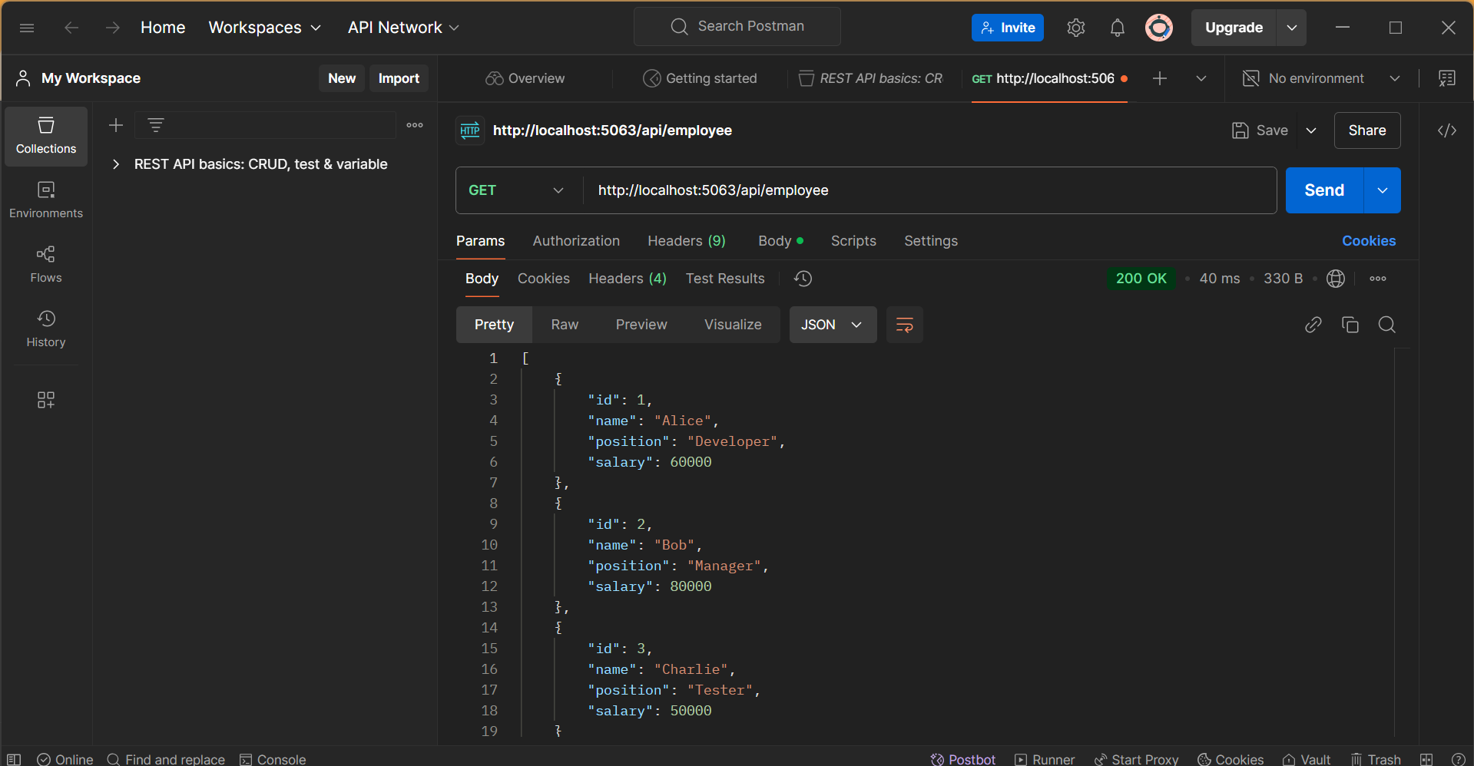
3.Modify the Controller name in the Route attribute of the Employee controller to ‘Emp’ and check its access thru POSTMAN
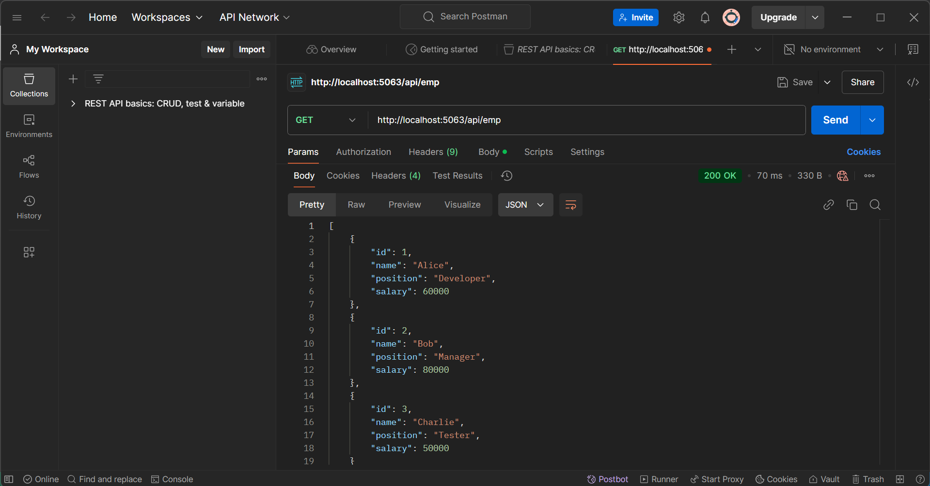
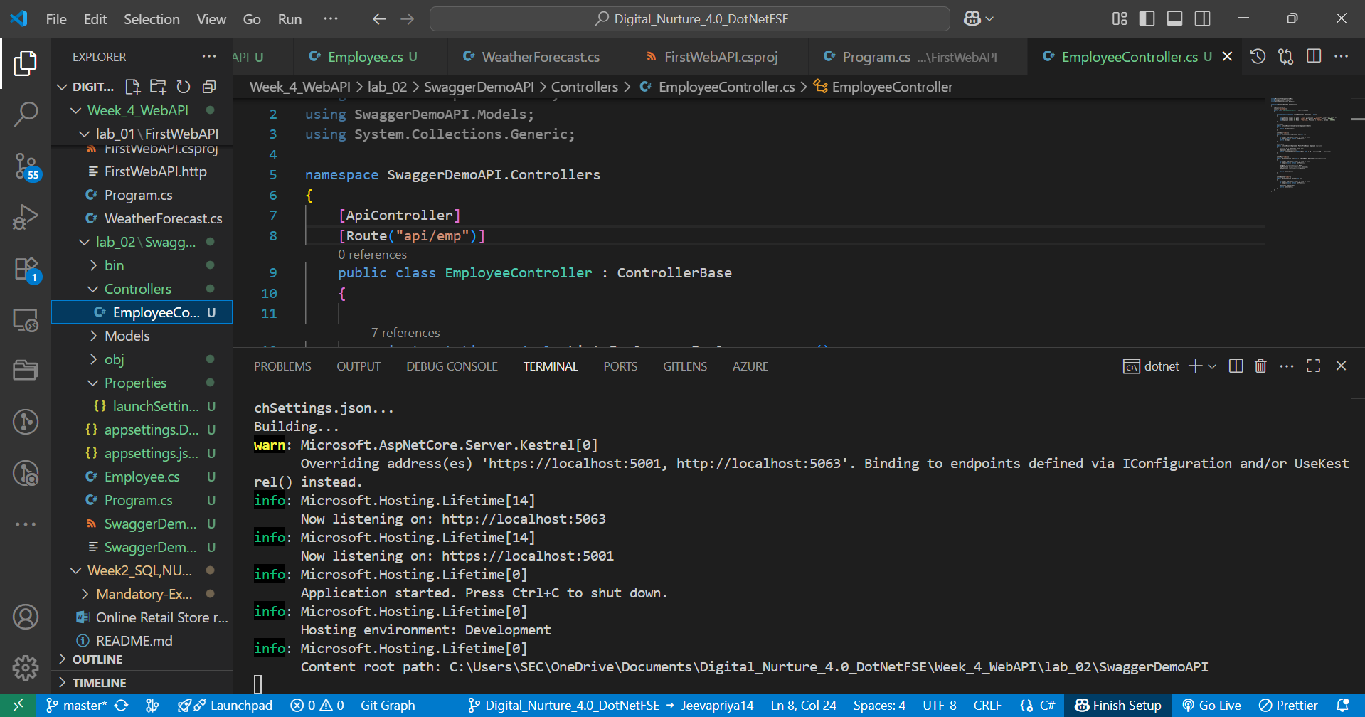
LAB 03:
OUTPUT:
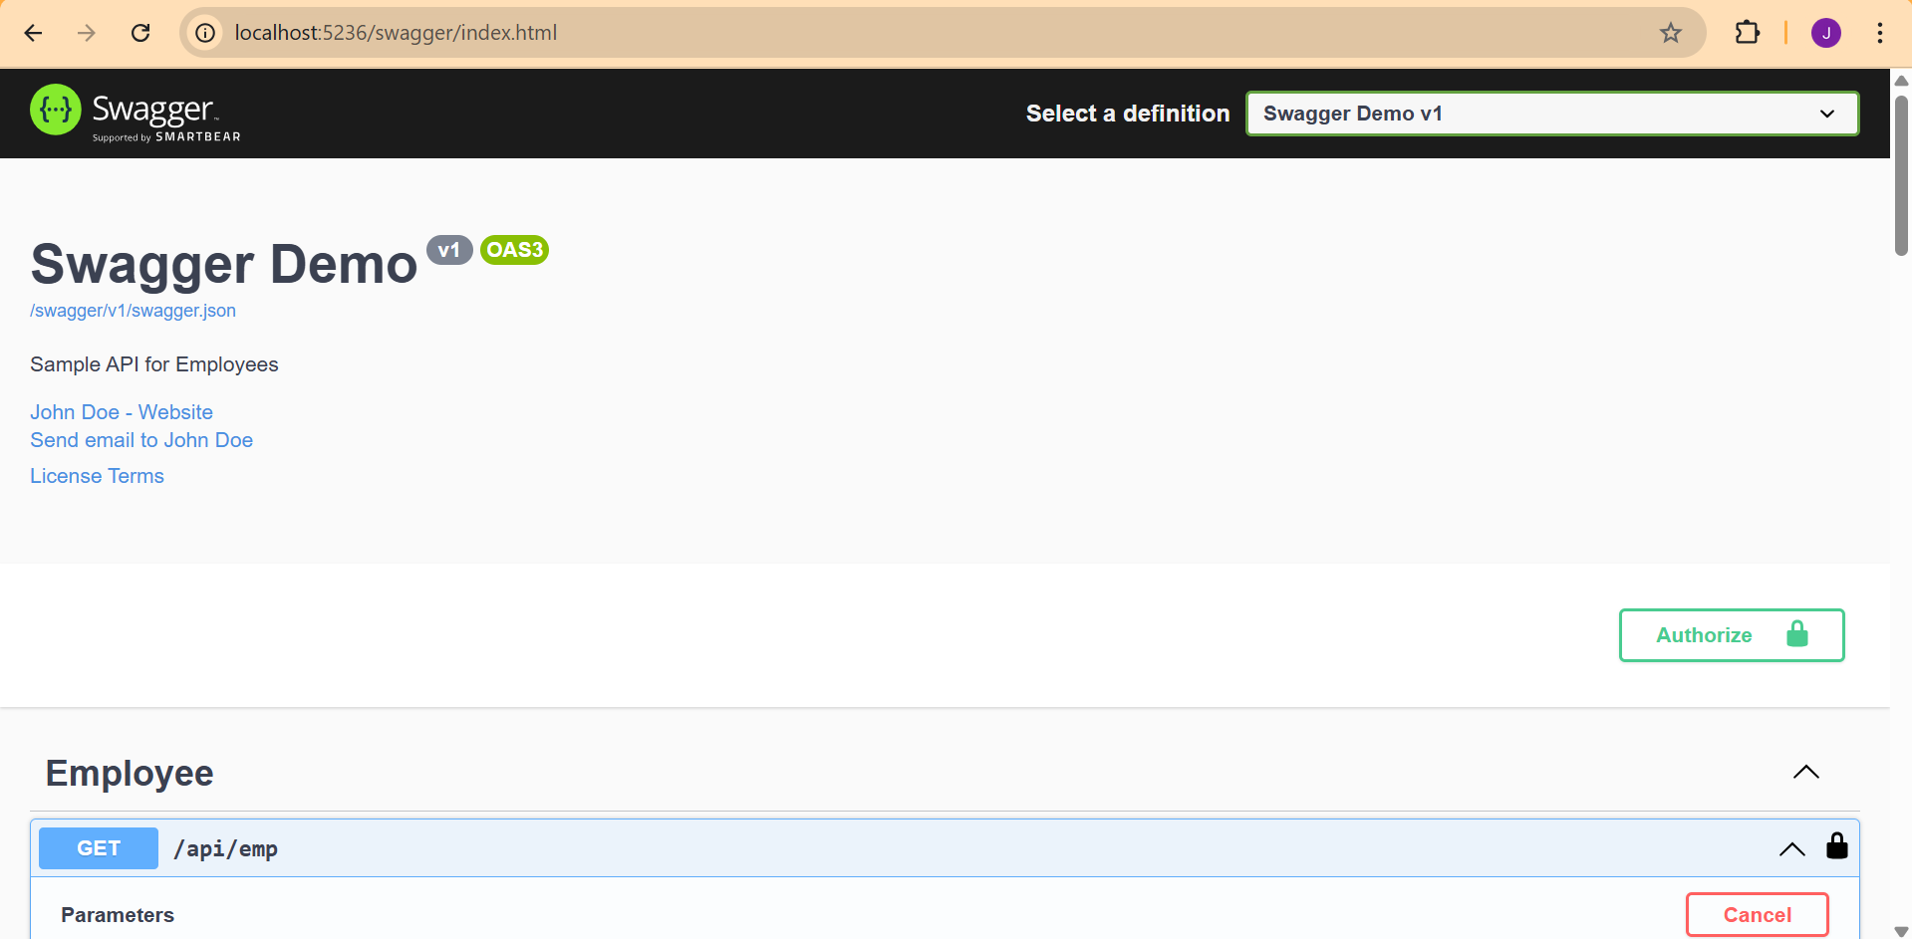
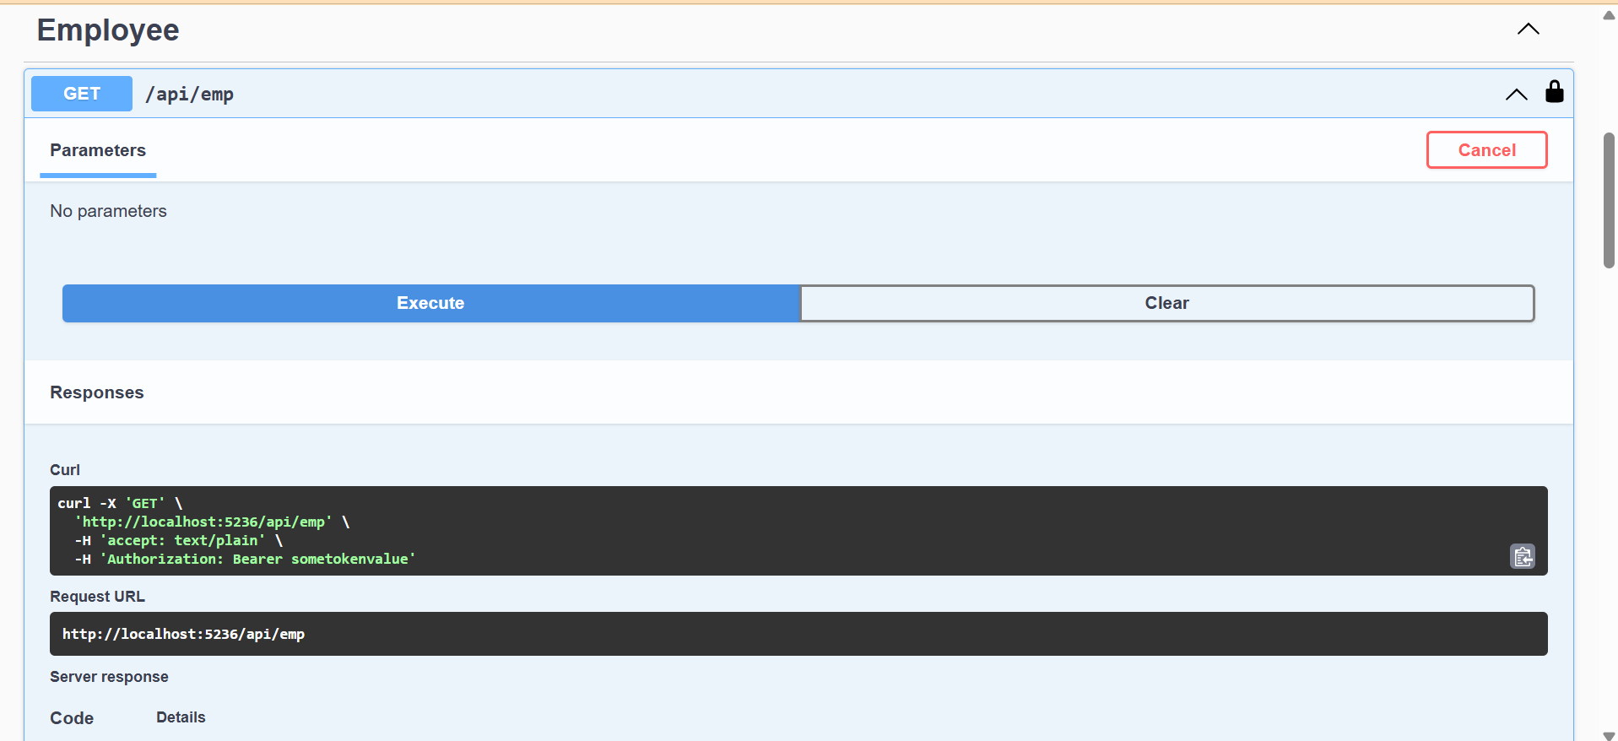
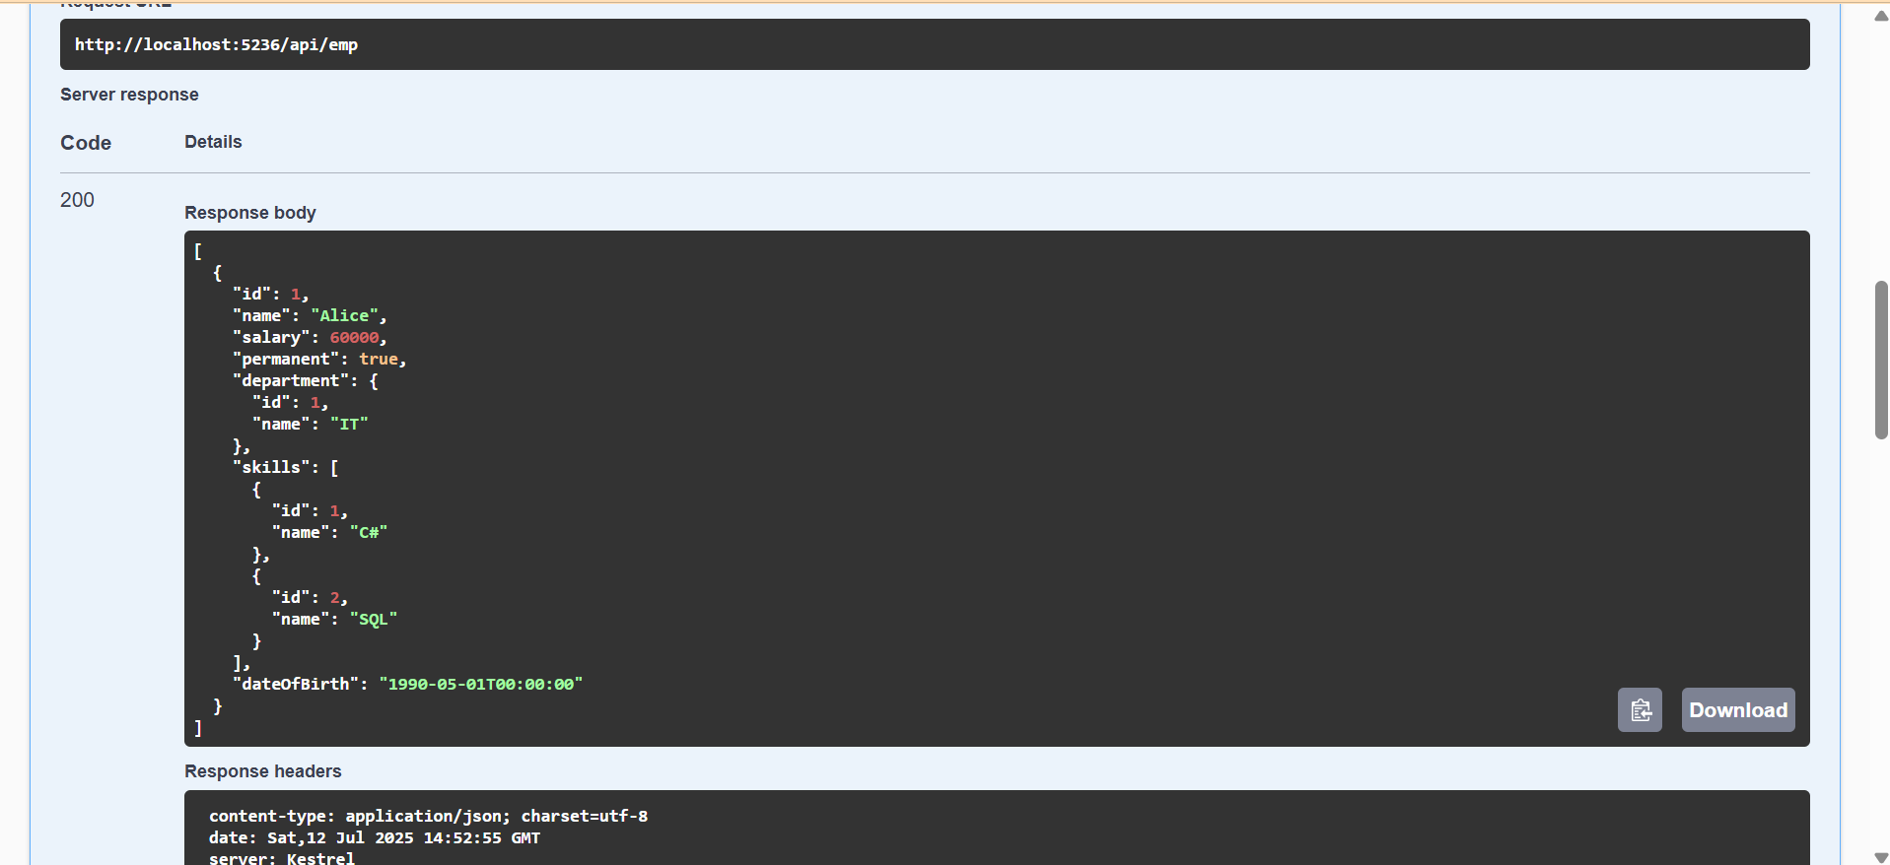
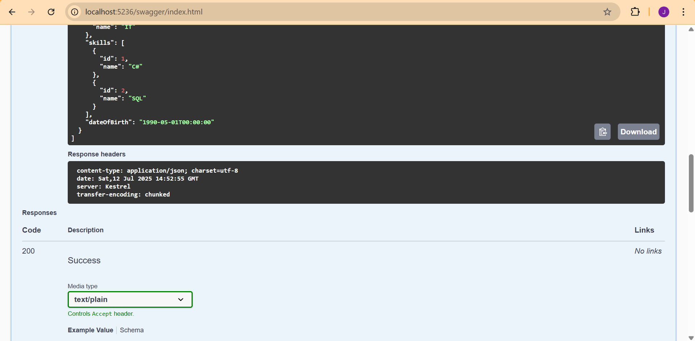
LAB 04:
OUTPUT:
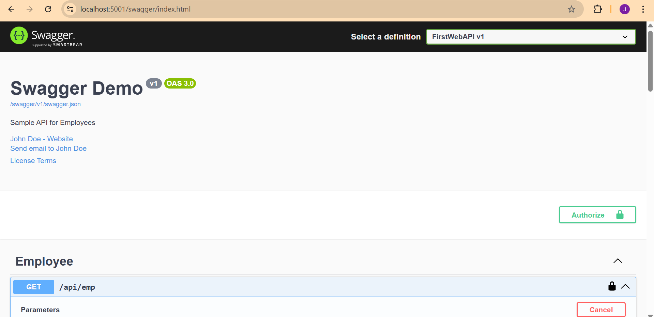
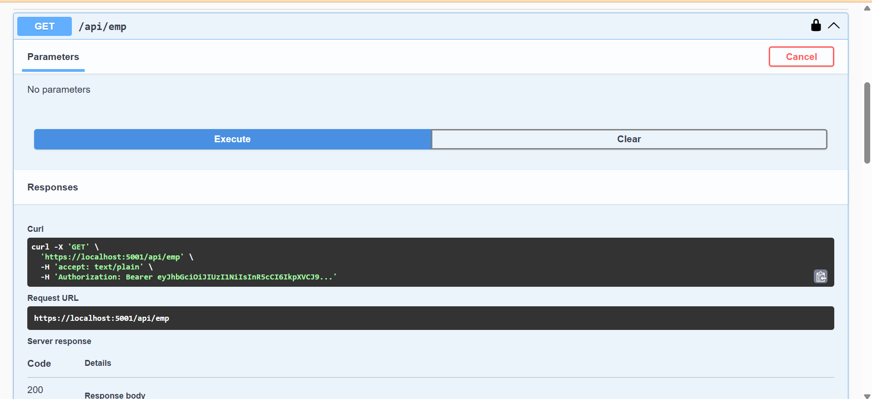
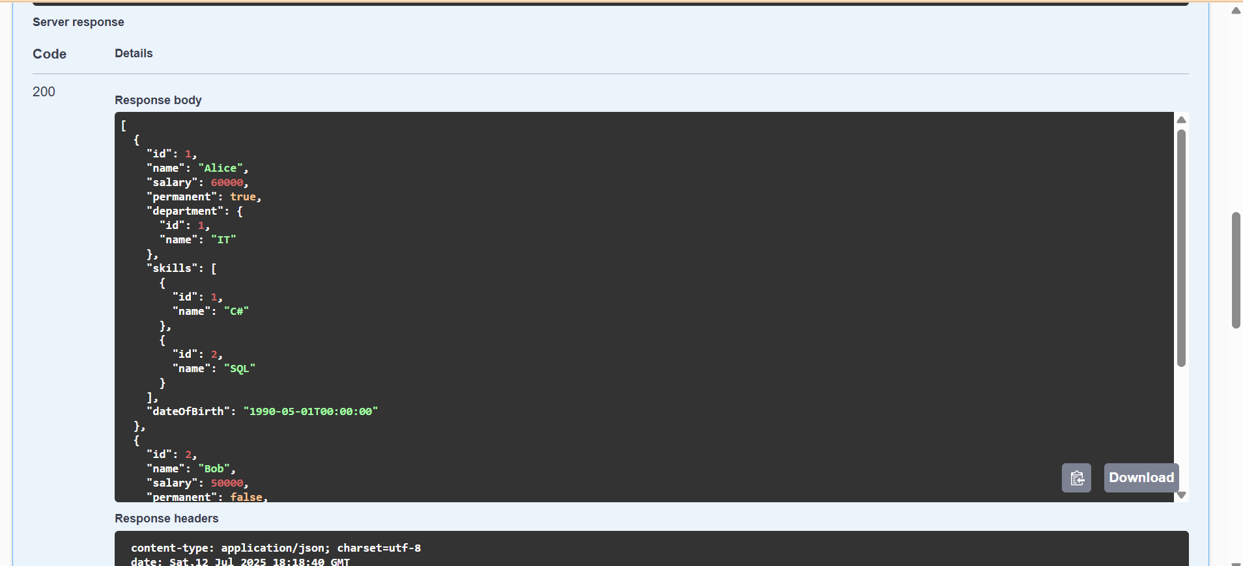
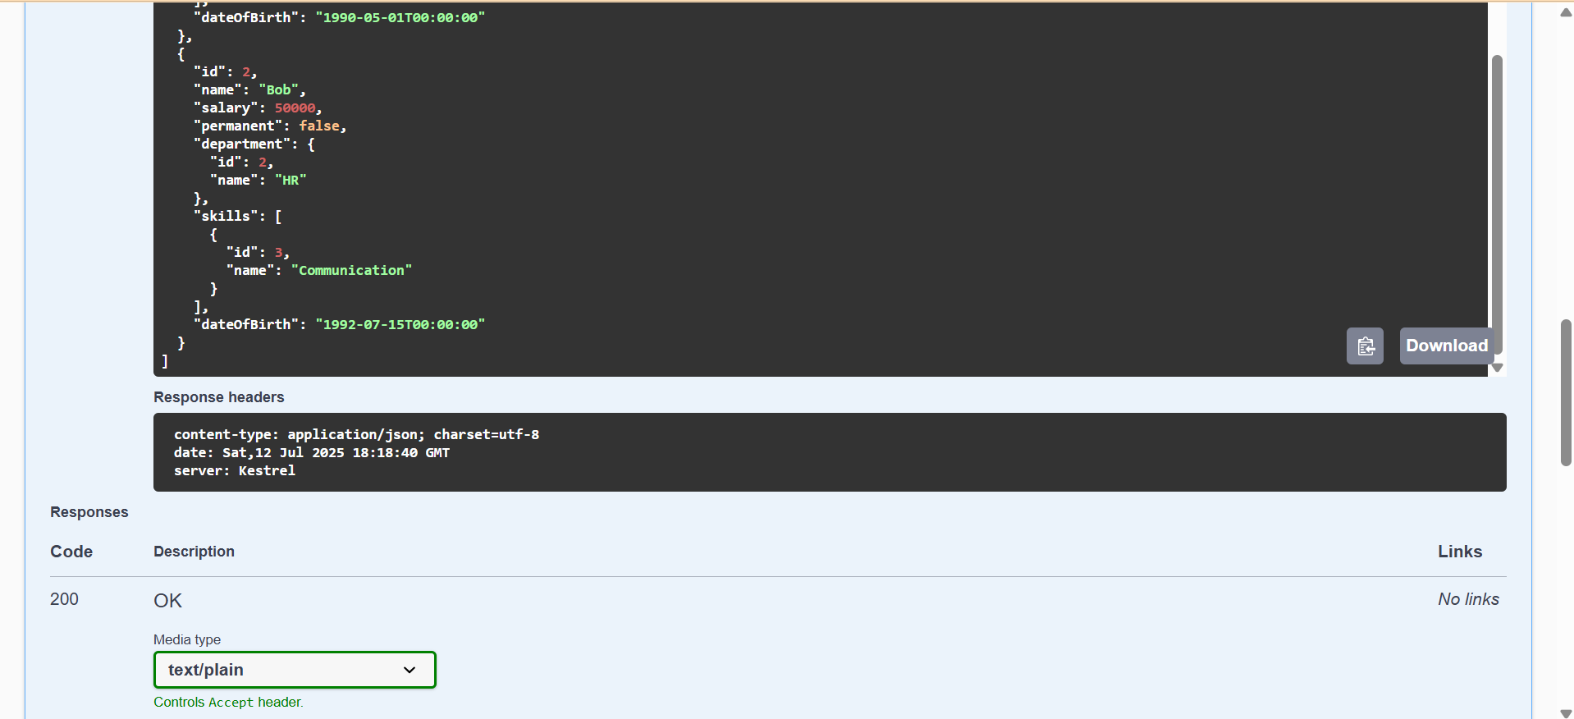
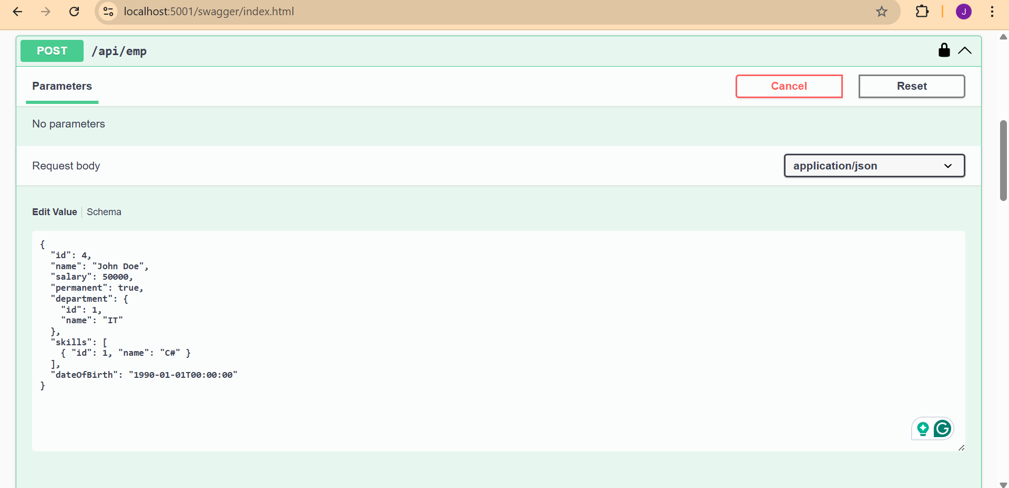
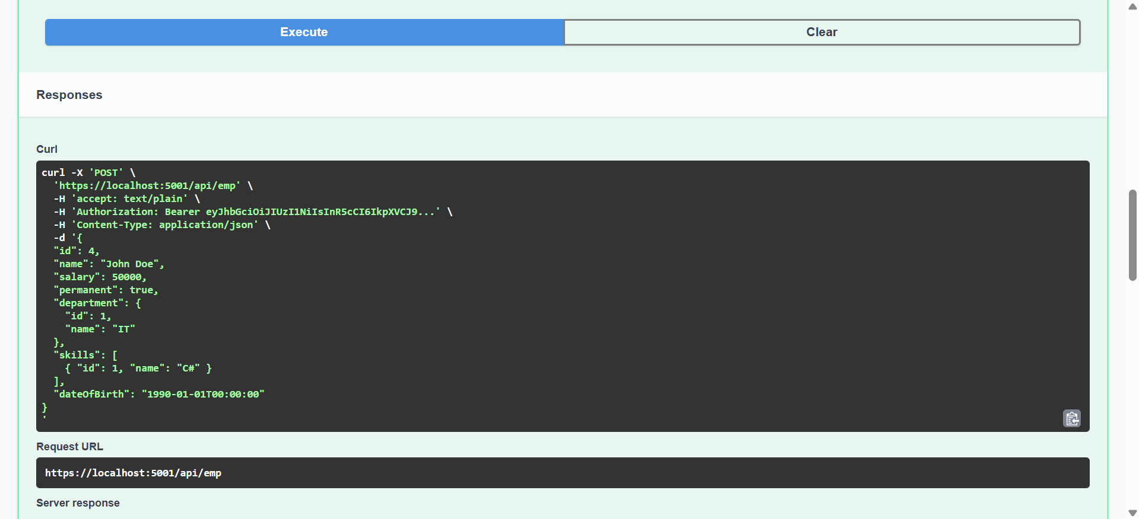
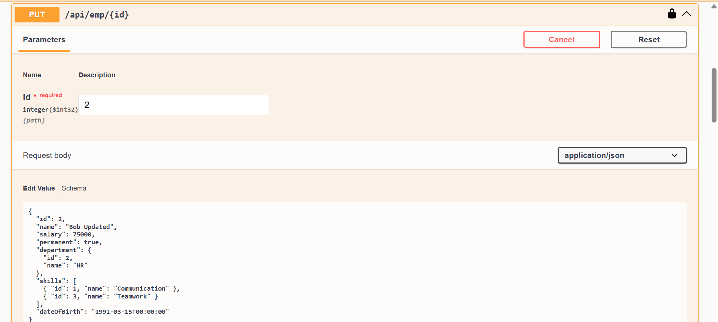
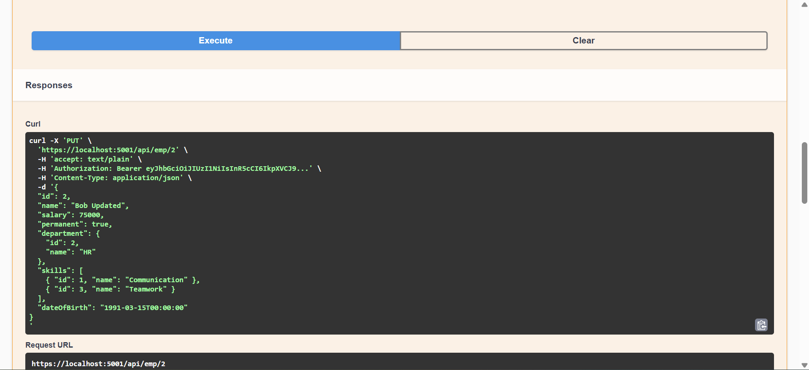
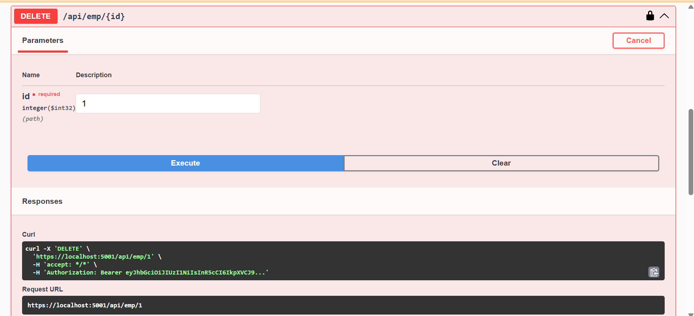
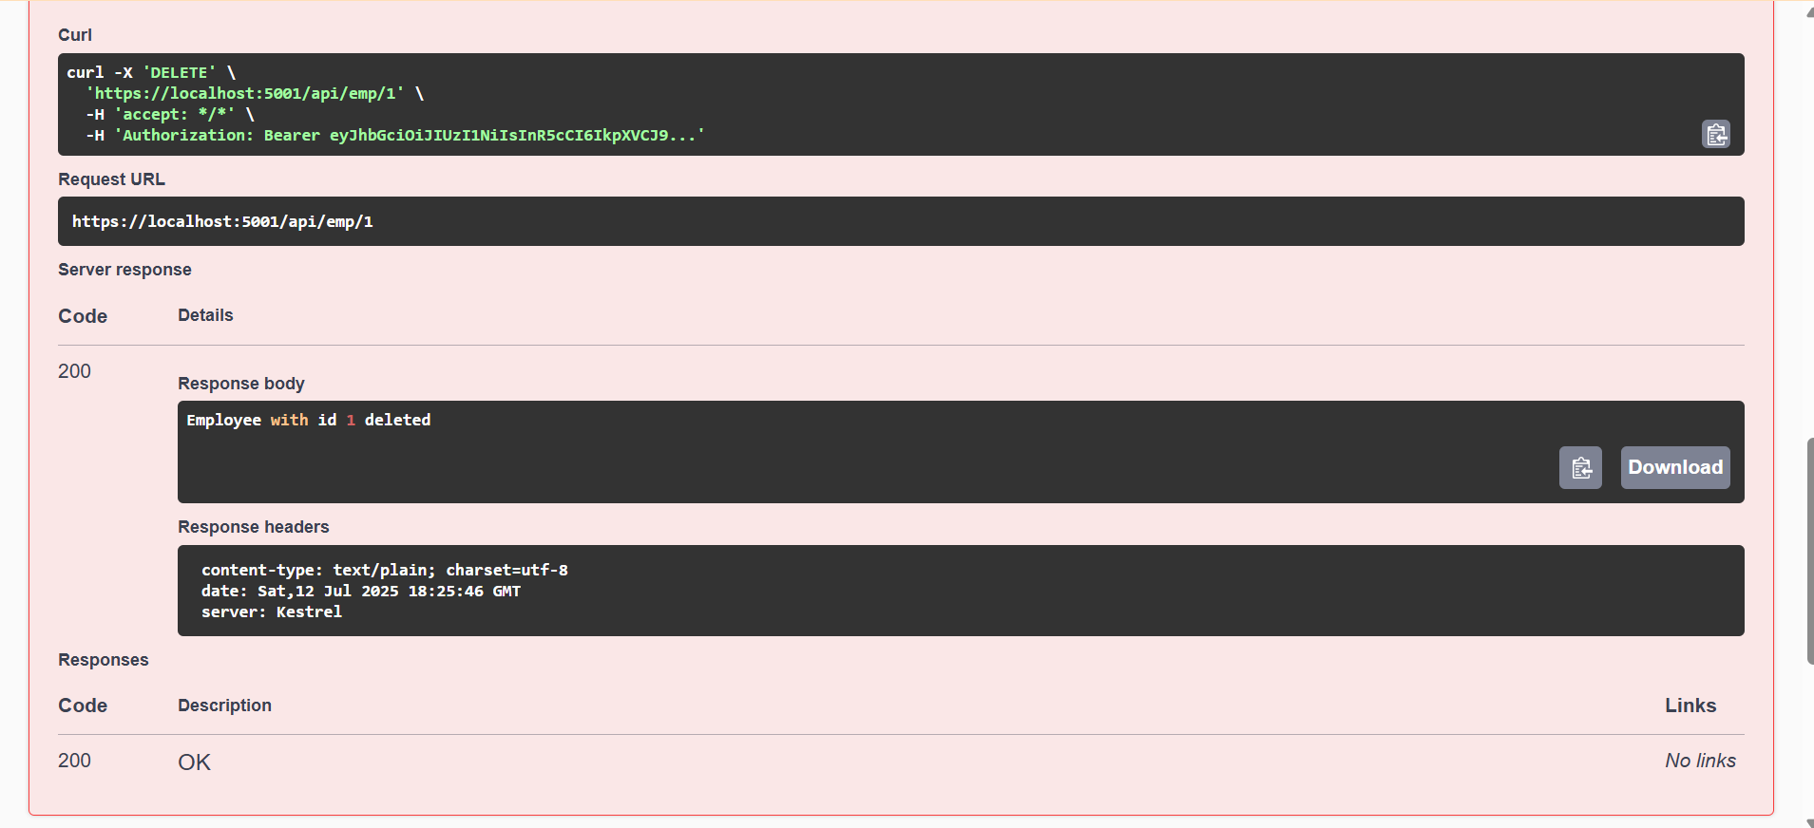
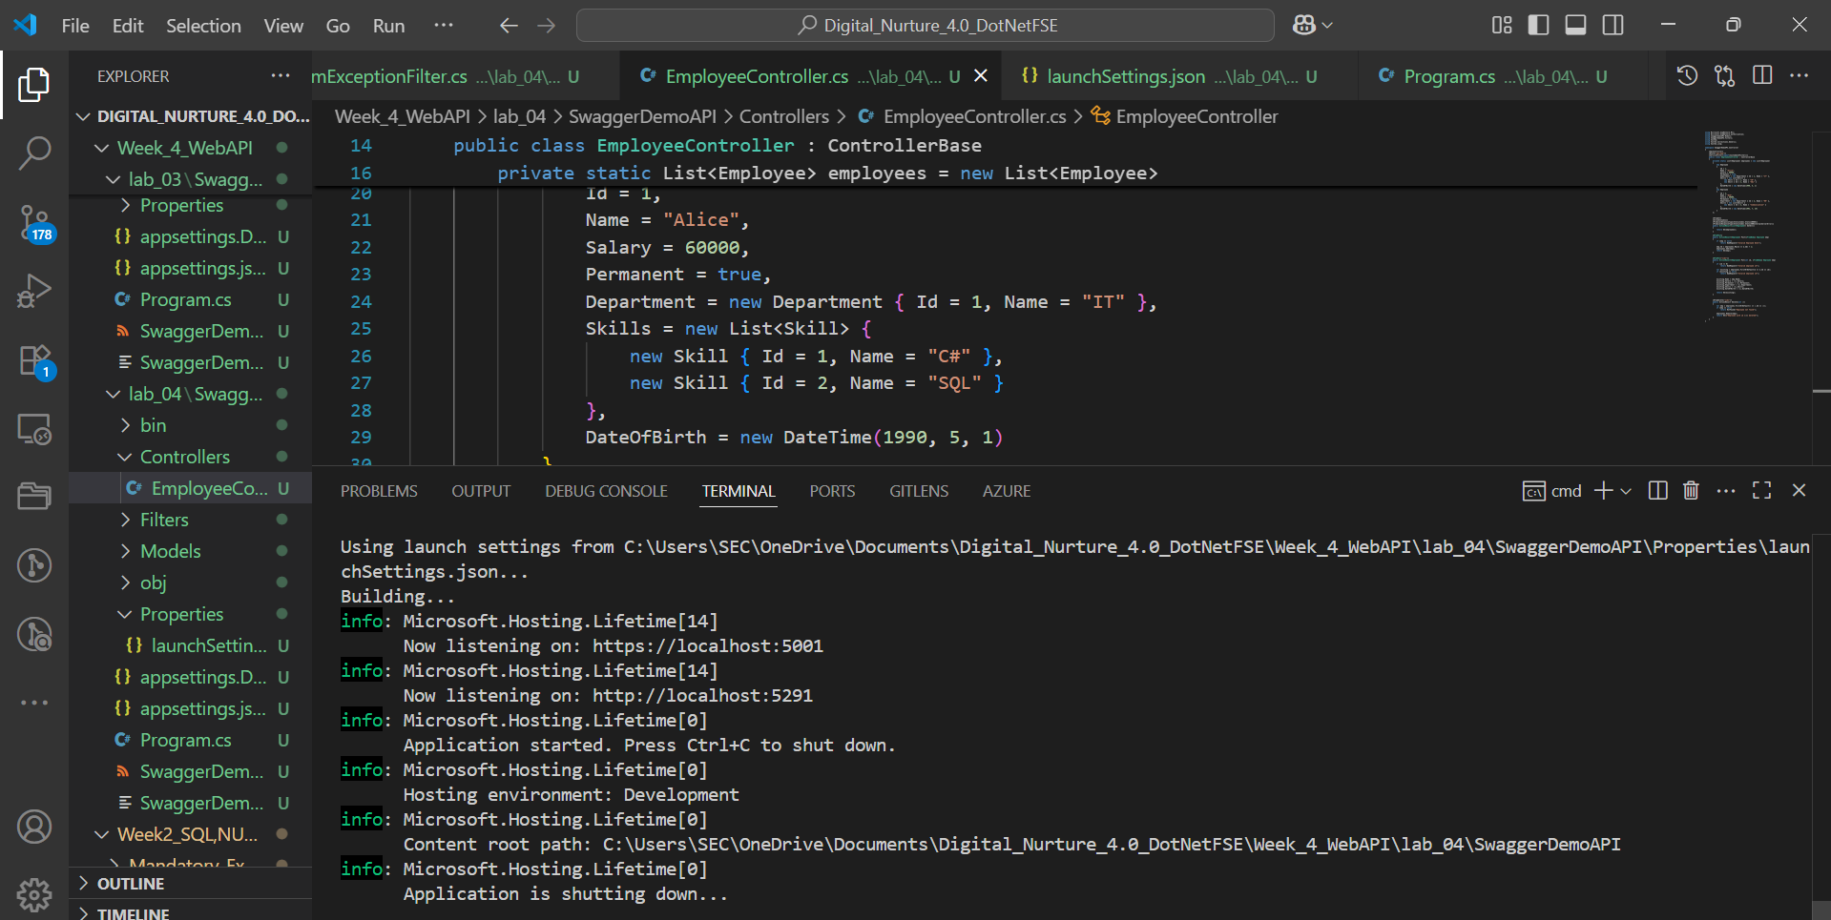
LAB 05:
OUTPUT:
